程序1：
#include<iostream>
using namespace std;
class Coordinate { // 定义Coordinate类
public: Coordinate()
{
times = 2;
cout << "Coordinate construction1 called!" << endl;
}
Coordinate(int times1)
{
times = times1;
cout << "Coordinate construction2 called!" << endl;
}
~Coordinate()
{
cout << "Coordinate destruction called!" << endl;
}

void InputCoord()
{
for (int i = 0; i < times; i++)
{
cout << "Please Input x:" << endl;
cin >> Coord[i][1];
cout << "Please Input y:" << endl;
cin >> Coord[i][2];
}
}
void ShowCoord()
{
cout << "The coord is:" << endl;
for (int i = 0; i < times; i++)
{
cout << "(" << Coord[i][1] << "," << Coord[i][2] << ")" << endl;
}
}
void ShowAvgCoord()
{
float avgx = 0;
float avgy = 0;
for (int i = 0; i < times; i++)
{
avgx = avgx + Coord[i][1];
avgy = avgy + Coord[i][2];
}

avgx = avgx / times;
avgy = avgy / times;
cout << "The AVG coord is:" << endl;
cout << "(" << avgx << "," << avgy << ")" << endl;
}
private:
float Coord[100][100]; // 存放输入坐标的数组
int times; // 存放输入坐标数目
};
int main()
{
Coordinate x; // 定义对象
x.InputCoord();
x.ShowCoord();
x.ShowAvgCoord();
return 0;
}
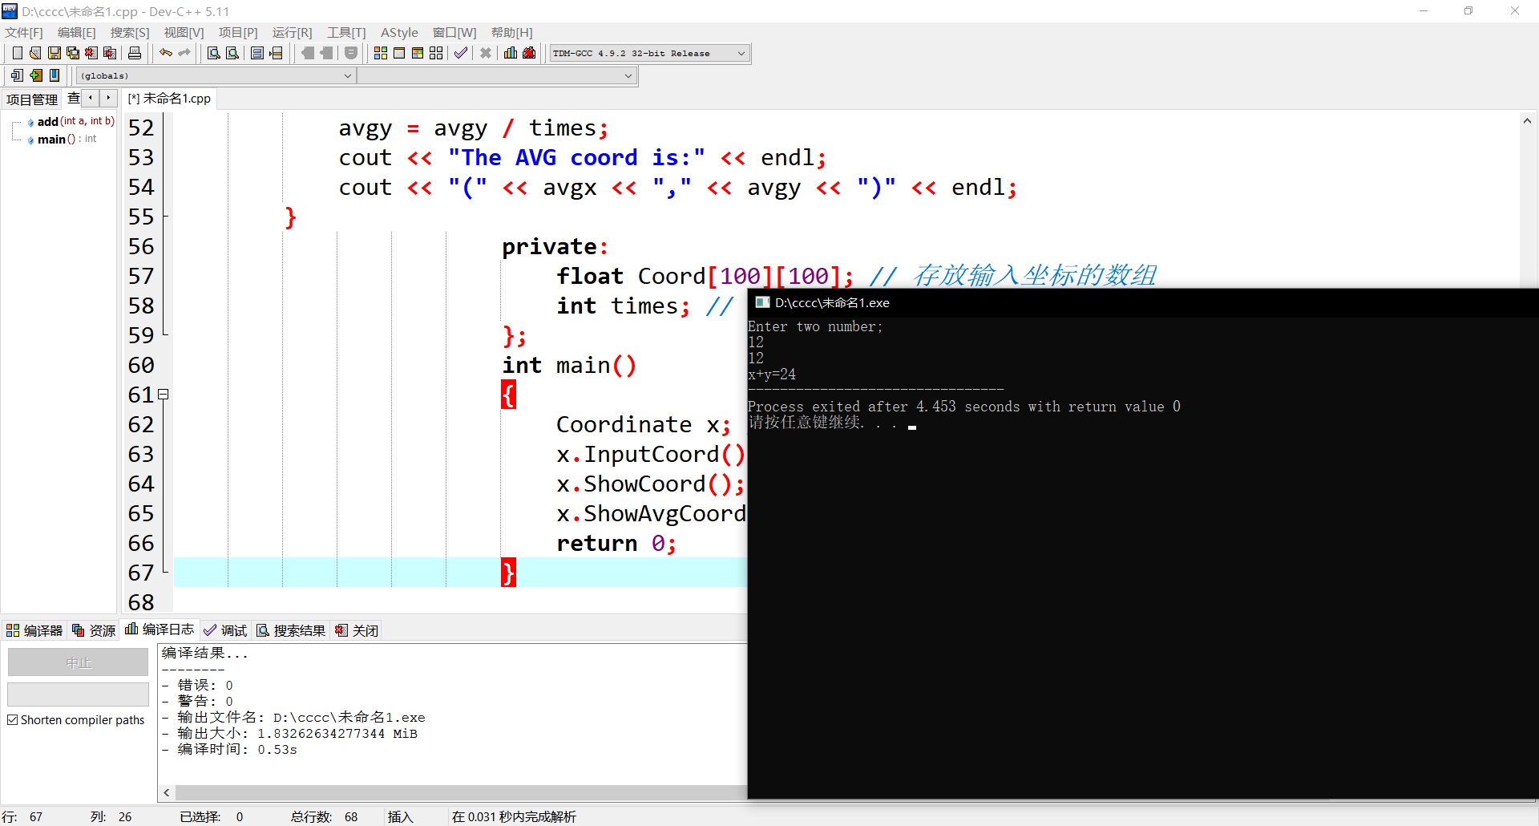
程序2:
#include<iostream>
using namespace std;

class Score
{
public:
Score(int stnumber=2)
{
if(stnumber>100)
number=100;
else number=stnumber;
}

void input()
{
for(int i=0;i<number;i++)
{
//输入姓名
cout<<"请输入学生姓名:"<<endl;
cin>>name[i];
//输入学生成绩
cout<<"请输入科目A成绩："<<endl;
cin>>grade[i][1];
cout<<"请输入科目B成绩："<<endl;
cin>>grade[i][2];
cout<<"请输入科目C成绩："<<endl;
cin>>grade[i][3];
}
}

void showallstu()
{
for(int i=0;i<number;i++)
{
cout<<"姓名："<<name[i]<<" 科目A成绩："<<grade[i][1]<< " 科目B成绩："<<grade[i][2]<<" 科目C成绩："<<grade[i][2]<<endl;
}
}

void showstuavg(int m)
{
cout<<"姓名:"<<name[m]<<" 平均成绩："<<(grade[m][1]+grade[m][2]+grade[m][3])/3<<endl;
}

void showavg(int i)
{
double all=0;
switch (i)
{
case 1:
for(int m=0;m<number;m++)
{
all+=grade[m][1];
};
cout<<"课程名称：A平均成绩："<<all/number<<endl;
break;
case 2:
for(int m=0;m<number;m++)
{
all+=grade[m][2];
};
cout<<"课程名称：B平均成绩："<<all/number<<endl;
break;
case 3:
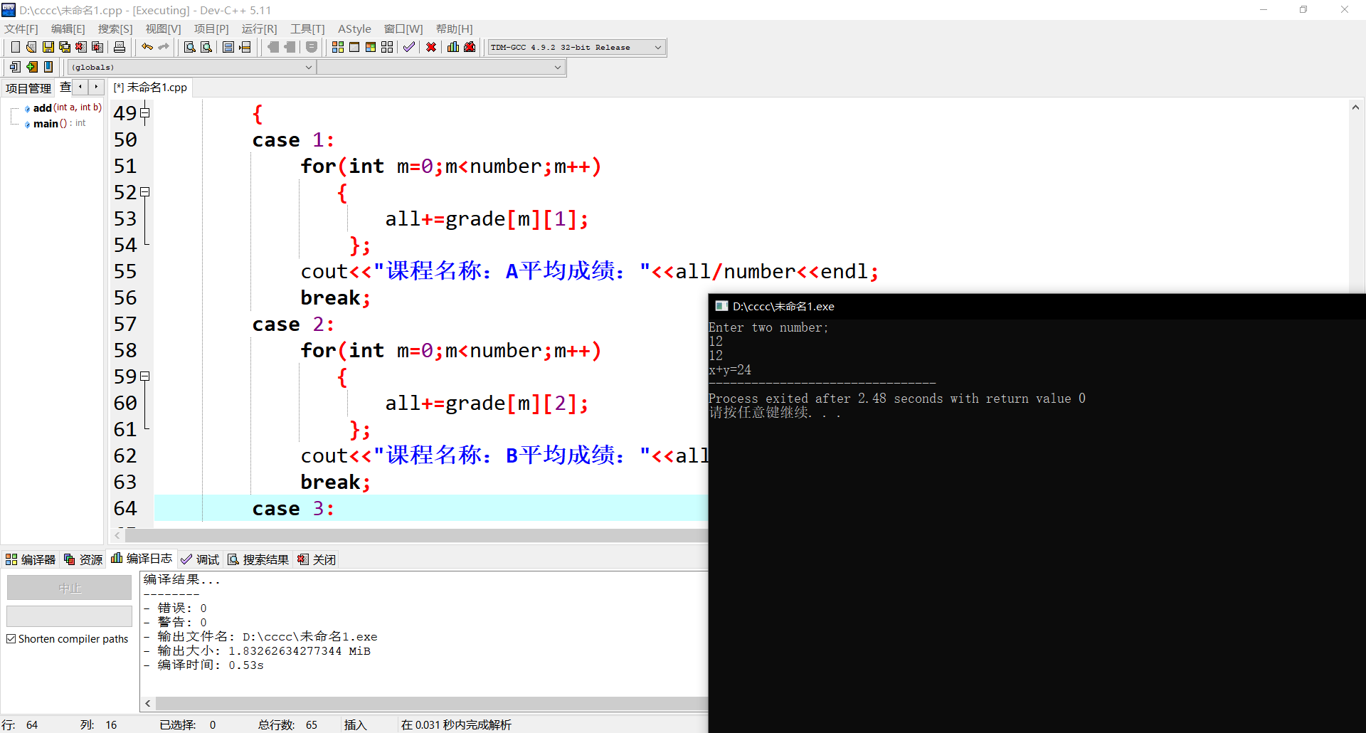
C++语言是一种结构化语言，是大部分编程语言的基础，c ++语言学好了，以后的java ,c#以及更多的编程语言才有可能学好。

